W-12
YEAR 10 SCIENCE
LIFE AND LIVING - GENETICS
REVISION

1. (a) What is the difference between the male and female sex chromosome pair?
(b) Who determines the sex of a child - the mother or father? Explain.

2. (a) Show, by punnett square, why half of any particular population would be expected to
be female.
(b) A family has had five girls born into it, and the mother is pregnant with the sixth child.
What is the chance that the child will be a girl? Explain why.

3. Briefly describe the significance of the work of Gregor Mendel to our understanding of genetics.

4. Define the following terms.

allele, pure-bred, hybrid, homozygous, heterozygous, genotype, phenotype, sex-linked,
dominant, recessive, co-dominant, incomplete dominance, haploid, diploid.

5. Give one example of how environment can affect how a characteristic shows in an individual.

6. In humans, the ability to taste a chemical phenylthiocarbamide (PTU) is due to the presence of the
dominant gene T.

(a) Determine the genotype and phenotypes of the offspring produced by the marriage of a
homozygous non-taster male and a heterozygous taster female.

(b) Study the pedigree chart below showing the occurrence of tasters in a family. A shaded square
or circle represents a taster. Determine the genotypes of every individual.

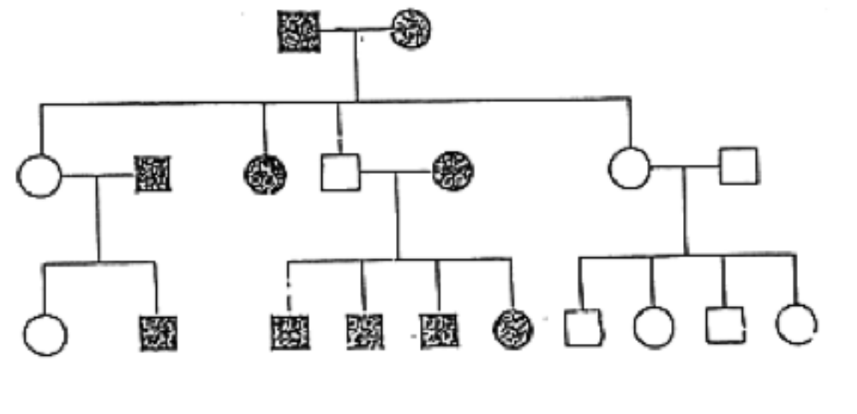

7. The pedigree below shows the existence of straight hair in a family.

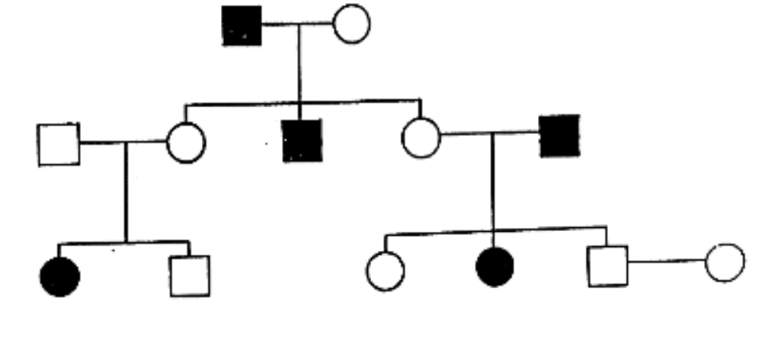

(a) Is straight hair a dominant or recessive trait? Explain your answer.

(b) Determine the genotype of all individuals.

8. Red-green colour blindness is a sex-linked, recessive disorder in humans. A colour blind male
marries a woman with normal colour vision. They have two girls, one of whom is colour blind,
and two boys, one of whom is colour blind.

What is the most likely genotype of the mother? Set out an appropriate cross or pedigree to
support your answer.

9. (a) Explain the difference between co-dominance and incomplete dominance. You may
need to give an example of each to help your explanation.

(b) In shorthorn cattle, red coat colour co-dominates with white coat colour, producing a
roan colour in a heterozygous animal. Determine the F1 and F2 generation offspring for
a red bull mated with a white cow. Set out your working.

(c) In snapdragon flowers, red colour is incompletely dominant over white. Hybrid plants
have pink flowers. Determine the genotypes and phenotypes for the offspring produced
from a red flowered plant with a pink one.

10. In guinea pigs, rough coat dominates smooth coat. Determine the genotypes and phenotypes
for the mating of two rough coated hybrid animals.

11. In humans, suppose that the gene that controls right-handedness is dominant over left-
handedness. A heterozygous right-handed male and a left-handed female have four children,
three of who are left-handed.

(a) If R represents the gene for right-handed, use a Punnett square to determine the expected
ratio of children that should be right-handed.

(b) Suggest a reason for difference between the result in part (a) and the actual proportion of
children in this family who are right-handed.

